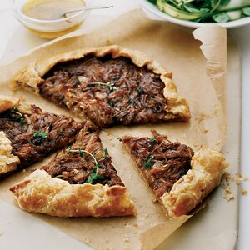 Free-Form Onion Tart / Food & Wine
Active: 40 mins Total: 2 hrs 15 mins Yield: 4 to 6
Ingredients
Dough
- 1 cup all-purpose flour
- 1/4 teaspoon salt
- 6 tablespoons unsalted butter, cut into small pieces and chilled
- 5 tablespoons ice cold water
Filling
- 4 tablespoons unsalted butter
- 2 1/2 pounds Walla Walla Sweet Onions, thinly sliced
- 6 thyme sprigs
- 2 tablespoons crème fraîche
- Salt and freshly ground pepper
- 1 egg beaten with 1 tablespoon of milk
Directions
- Step 1 In a bowl, whisk the flour with the salt. Using your fingers, rub the butter into the flour until the mixture resembles coarse meal. Drizzle the water over the flour and stir gently just until incorporated; gently press to form a dough. Flatten the dough into a disk, wrap in plastic and refrigerate for 1 hour.
- Step 2 In a skillet, melt the butter. Add the onions and thyme and cook over moderately high heat, until softened, about 10 minutes. Reduce the heat to moderately low and cook, until the onions are golden, 20 minutes longer. Remove from the heat and discard the thyme. Stir in the crème fraîche and season with salt and pepper. Let cool.
- Step 3 Set a pizza stone on the bottom of the oven or position a rack on the lowest rung and preheat the oven to 375°. Line a large baking sheet with parchment paper. On a floured work surface, roll out the dough to a 12-inch round and transfer to the baking sheet. Spread the onions on the round, leaving a 1 1/2-inch border. Fold the edge of the dough up and over the filling and brush the edge with the egg wash.
- Step 4 Bake the tart on the stone or on the bottom shelf for about 40 minutes, until the dough is richly browned on the bottom.
- Step 5 Transfer the tart to the top shelf and bake for about 5 minutes longer, until the top of the crust is browned. Transfer the tart to a rack and let cool slightly. Cut the warm tart into wedges and serve.

