Ottolenghi’s Stuffed Walla Walla Sweet Onions
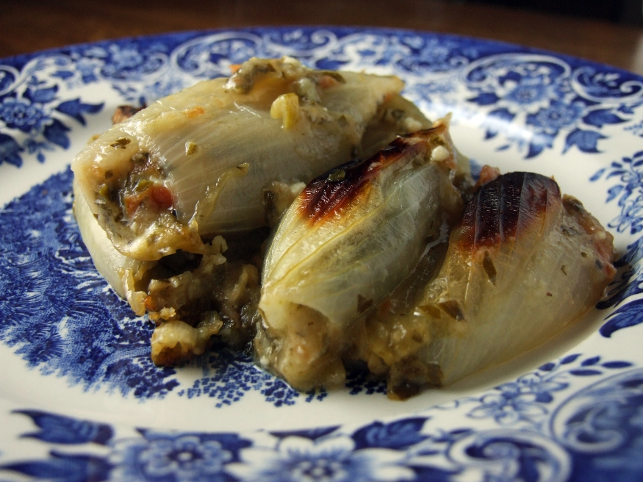
Yotam Ottolenghi
(in theory, they could serve 4 but there’s no chance to be honest. Serves 2).
INGREDIENTS
500ml veg stock
350ml white wine
4 large Walla Walla Sweet Onions
3 small tomatoes
120g white breadcrumbs
90g feta, crumbled
80g parsley leaves, finely chopped
3 tablespoons olive oil
3 spring onions, finely chopped
3/4 teaspoon salt
Black pepper
Butter, for greasing the dish
INSTRUCTIONS
Preheat the oven to 180C and grease a baking dish with butter.
Combine the wine and stock in a saucepan and bring to the boil. While this is happening, trim the top and bottom from the onions, cut them lengthways in half and remove the skin. Carefully remove most of the insides to leave 3 or 4 outer layers of onion. Carefully separate these. Turn the stock to a simmer and put the onion layers in it, a few at a time. Cook them for 3-4 minutes or until just tender then set aside. Keep the stock.
To make the stuffing, grate the tomatoes into a bowl using a coarse cheese grater. Most of the skin will be left behind in your hands and you can discard it. Add the feta, breadcrumbs, parsley, olive oil, spring onions, salt and some pepper. Mix well.
Fill each onion layer generously and roll into a ‘fat cigar shape’. Place fold side down in the dish. Pour over about 75ml of the stock. Bake for 45-50 minutes or until they are brown and charred in places and bubbling underneath. You can add more stock if they look like they’re drying up during cooking. Serve warm.

