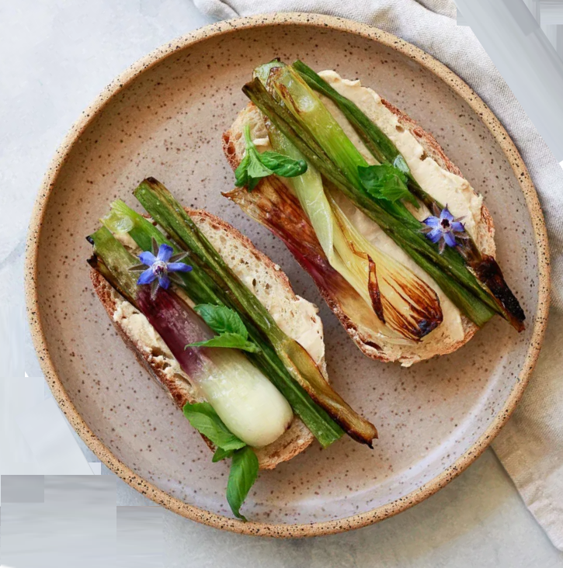
YIELD: 2 SLICES

SPRING ONION TOASTS
Crusty sourdough or French bread toasts with hummus and charred spring onions are a delicious lunch or snack.
PREP TIME 2 minutes
COOK TIME 5 minutes
TOTAL TIME 7 minutes

INGREDIENTS
- 1 Walla Walla Sweet Spring Onion, halved lengthwise
- 1 tablespoon extra virgin olive oil
- sea salt to taste
- 2 slices fresh crusty French or sourdough bread, lightly toasted
- 2 tablespoons favorite hummus
- fresh basil, other herbs, or arugula

INSTRUCTIONS
Trim the top 2-3" off the spring onion greens. Cut off any of the little hair-like roots at the bottom of the bulb. Cut the spring onion in half again crosswise. Coat a cast iron skillet with cooking spray or olive oil and place over medium heat. Place the onions cut-side-down on the hot skillet and sprinkle with sea salt. Sear until browned, about 2 minutes. Flip over and continue to cook until tender, another minute or two. Spread hummus over the toast and place spring onions on top. Garnish with fresh herbs or arugula.

